**Project Name: Funeral Seva**

**Project Members:**

**Namrata Wange 220343120063**

**Tejashri Sutar 220343120108**

**Omkar More 220343120062**

**Abstract:**

In our religions, conducting the funeral service of our loved ones is very crucial as it allows the souls of the deceased to achieve some peace. When a loved one passes away, it becomes very difficult for the mourning family to run here and there to make all the necessary funeral arrangements. So we made a system that helps and provide all the information about funeral rites on one click. We provide all the information and the *samagri* needed for cremation. This System will help people to keep them connected with their culture.

* **Implementation Technologies:**

1. Frontend- React
2. Backend- Java, Spring
3. Database- MySQL database
4. Others – Eclipse IDE
5. **Spring Framework:**

Spring is the most popular application development framework for enterprise Java. Millions of developers around the world use Spring Framework to create high performing, easily testable, and reusable code.

The core features of the Spring Framework can be used in developing any Java application, but there are extensions for building web applications on top of the Java EE platform. Spring framework targets to make J2EE development easier to use and promotes good programming practices by enabling a POJO-based programming model.

* 1. Features of Spring Framework:

**1. Lightweight**

Spring is modular lightweight framework which allows you to selectively use any of its modules on the top of Spring Core.

**2. Inversion of Control (IOC)**

This is another top feature of spring framework where application dependencies are satisfied by the framework itself. Framework creates the object in runtime and satisfies application dependencies.

**3. Aspect Oriented Programming (AOP)**

Aspect Oriented Programming (AOP) is very popular in programming world and in spring it is well implemented. Developer can use Aspect Oriented Programming (AOP feature of spring to develop application in which business logic is separated from system services.

**4. Container**

Spring provides their own container for managing the bean lifecycle.

**5. MVC Framework**

Spring MVC Framework is used for developing MVC based web applications.

**6. Transaction Management**

Spring framework provides generic Transaction Management layer which can be used with or without J2EE (JEE) environment.

**7. JDBC Exception Handling**

Spring provides their own abstraction of JDBC exception which further simplifies the exception handling in program.

**1.2 Advantages of Spring Framework:**

**1. Solving difficulties of Enterprise application development**

Spring is solving the difficulties of development of complex applications, it provides Spring Core, Spring IoC and Spring AOP for integrating various components of business applications.

**2. Support Enterprise application development through POJOs**

Spring supports development of Enterprise application development using the POJO classes which removes the need of importing heavy Enterprise container during development. This makes application testing much easier.

**3. Easy integration other frameworks**

Spring designed to be used with all other frameworks of Java, you can use ORM, Struts, Hibernate and other frameworks of Java together. Spring framework do not impose any restriction on the frameworks to be used together.

**4. Application Testing**

Spring Container can be used to develop and run test cases outside enterprise container which makes testing much easier.

**5. Modularity**

Spring framework is modular framework and it comes with many modules such as Spring MVC, Spring ORM, Spring JDBC, Spring Transactions etc. which can used as per application requirement in modular fashion.

**6. Spring Transaction Management**

Spring Transaction Management interface is very flexible it can configure to use local transactions in small application which can be scaled to JTA for global transactions.

1. **MySQL**

MySQL, the most popular Open Source SQL database management system, is developed, distributed, and supported by Oracle Corporation.

**Features of MySQL:**

* **MySQL is a database management system.**

A database is a structured collection of data. It may be anything from a simple shopping list to a picture gallery or the vast amounts of information in a corporate network. To add, access, and process data stored in a computer database, you need a database management system such as MySQL Server. Since computers are very good at handling large amounts of data, database management systems play a central role in computing, as standalone utilities, or as parts of other applications.

* **MySQL databases are relational.**

A relational database stores data in separate tables rather than putting all the data in one big storeroom. The database structures are organized into physical files optimized for speed. The logical model, with objects such as databases, tables, views, rows, and columns, offers a flexible programming environment.

* **MySQL software is Open Source.**

Open Source means that it is possible for anyone to use and modify the software. Anybody can download the MySQL software from the Internet and use it without paying anything.

* **The MySQL Database Server is very fast, reliable, scalable, and easy to use.**

MySQL Server was originally developed to handle large databases much faster than existing solutions and has been successfully used in highly demanding production environments for several years. Although under constant development, MySQL Server today offers a rich and useful set of functions. Its connectivity, speed, and security make MySQL Server highly suited for accessing databases on the Internet.

* **MySQL Server works in client/server or embedded systems.**

The MySQL Database Software is a client/server system that consists of a multithreaded SQL server that supports different back ends, several different client programs and libraries, administrative tools, and a wide range of application programming interfaces (APIs).

* **Hardware and Software Requirements (Minimum):**

**Hardware:**

1. Intel i3 processor 3rd generation or later

2. 2 GB ddr3 ram.

3. Windows 7 Home edition or later.

4. 200 GB HDD Space

5. Data Connection 200 kbps

**Software:**

1. Eclipse Oxygen
2. MySQL with Workbench 8.0 CE
3. Google Chrome version 79.0
4. Maven Dependencies

* **Flow Diagram:**

Level 0:

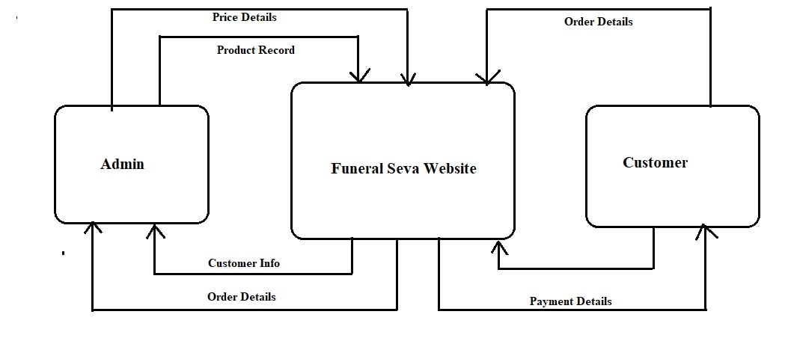

Level 1:

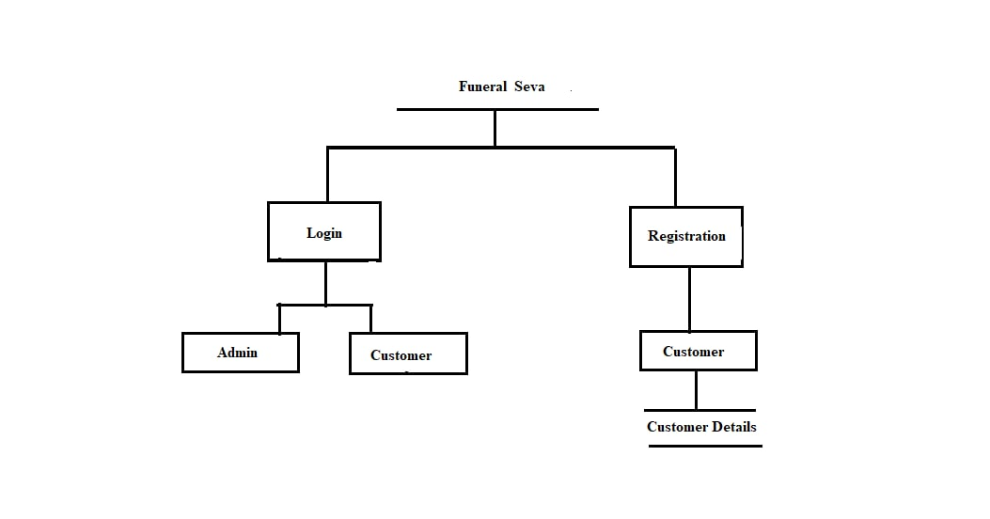

1. **ER Diagram**

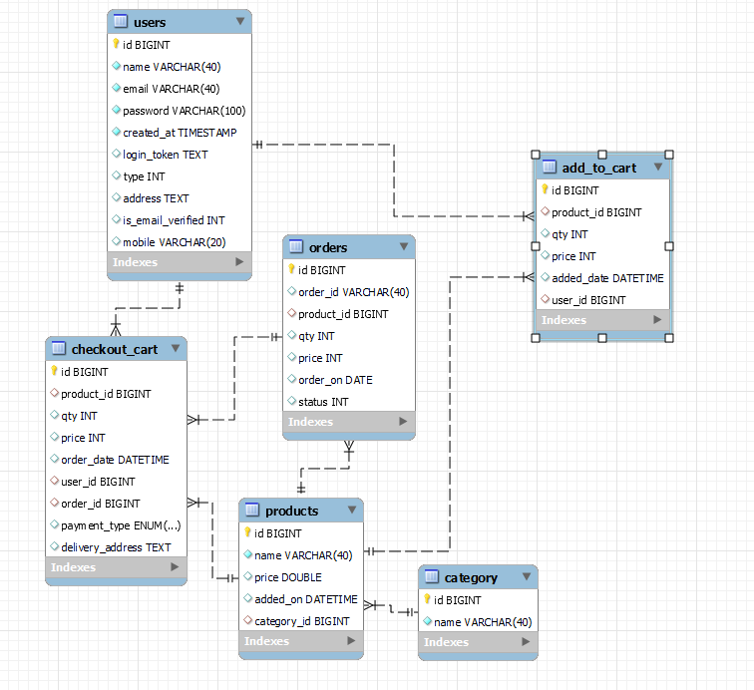

* **Table Structures:**

1. **Table name: Add_to_cart**

|  |  |  |  |  |  |
| --- | --- | --- | --- | --- | --- |
| id | bigint | NO | PRI |  | auto_increment |
| product_id | bigint | YES | MUL |  |  |
| qty | int | YES |  |  |  |
| price | int | YES |  |  |  |
| added_date | datetime | YES |  | CURRENT_TIMESTAMP | DEFAULT_GENERATED |
| user_id | bigint | YES | MUL |  |  |

1. **Table name: Users**

|  |  |  |  |  |  |
| --- | --- | --- | --- | --- | --- |
| id | bigint | NO | PRI |  | auto_increment |
| name | varchar(40) | NO |  |  |  |
| email | varchar(40) | NO |  |  |  |
| password | varchar(100) | NO |  |  |  |
| created_at | timestamp | NO |  | CURRENT_TIMESTAMP | DEFAULT_GENERATED |
| login_token | text | YES |  |  |  |
| type | int | YES |  |  |  |
| address | text | YES |  |  |  |
| is_email_verified | int | YES |  |  |  |
| mobile | varchar(20) | YES |  |  |  |

1. **Table name: Products**

|  |  |  |  |  |  |
| --- | --- | --- | --- | --- | --- |
| Id | bigint | NO | PRI |  | auto_increment |
| name | varchar(40) | NO |  |  |  |
| price | double | YES |  |  |  |
| added_on | datetime | YES |  | CURRENT_TIMESTAMP | DEFAULT_GENERATED |
| category_id | bigint | YES | MUL |  |  |

1. **Table name: Orders**

|  |  |  |  |  |  |
| --- | --- | --- | --- | --- | --- |
| id | bigint | NO | PRI |  | auto_increment |
| order_id | varchar(40) | YES |  |  |  |
| product_id | bigint | YES | MUL |  |  |
| qty | int | YES |  |  |  |
| price | int | YES |  |  |  |
| order_on | date | YES |  |  |  |
| status | int | YES |  |  |  |

1. **Table Name: Checkout_cart**

|  |  |  |  |  |  |
| --- | --- | --- | --- | --- | --- |
| id | bigint | NO | PRI |  | auto_increment |
| product_id | bigint | YES | MUL |  |  |
| qty | int | YES |  |  |  |
| price | int | YES |  |  |  |
| order_date | datetime | YES |  | CURRENT_TIMESTAMP | DEFAULT_GENERATED |
| user_id | bigint | YES | MUL |  |  |
| order_id | bigint | YES | MUL |  |  |
| payment_type | enum('COD','ONLINE') | YES |  |  |  |
| delivery_address | text | YES |  |  |  |

1. **Table Name: Categary**

|  |  |  |  |  |  |
| --- | --- | --- | --- | --- | --- |
| Id | bigint | NO | PRI |  | auto_increment |
| Name | varchar(40) | NO |  |  |  |

THANK YOU